LAB LOGBOOK

WEEK 11

Student ID (SID): 2458261
Last Two Digits of SID: 61
Since 61 is greater than 50, it is divided by 2:
61 ÷ 2 = 30.5 → Rounded up = 31
Selected Epoch Number: 31

Training Output Details:
- Epoch Number: 31
- Time Taken for Epoch: 13.45 seconds

EPOCH 1: EPOCH 15:

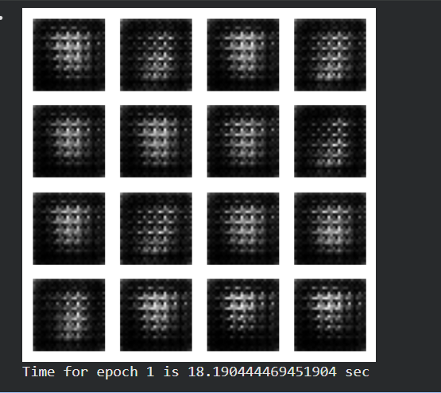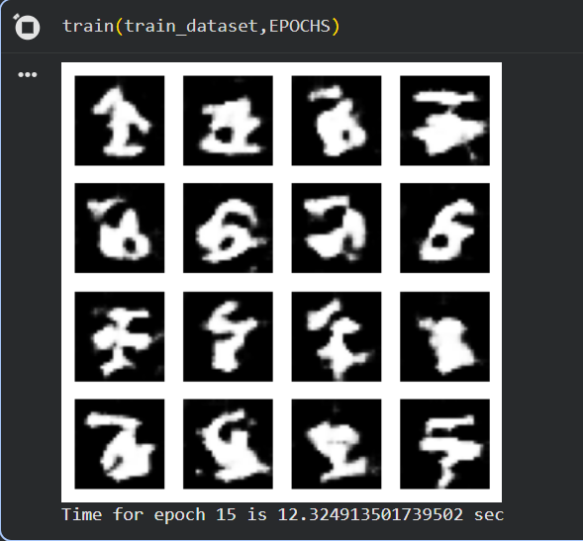

SID - EPOCH : 31 EPOCH : 60

